Math 1 Name_________________________

**4-2 Exponential Growth** Date________

* *I can define an exponential function.*
* *I can convert a sequence into a recursive or explicit formula.*

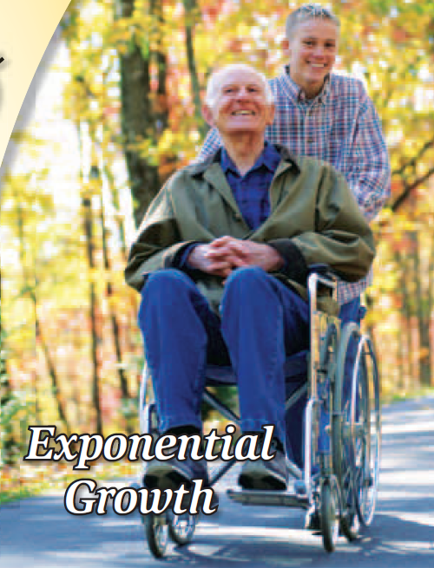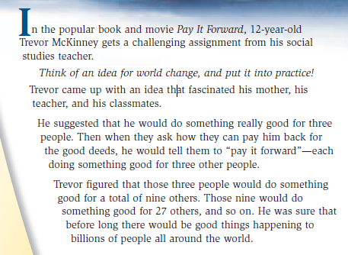

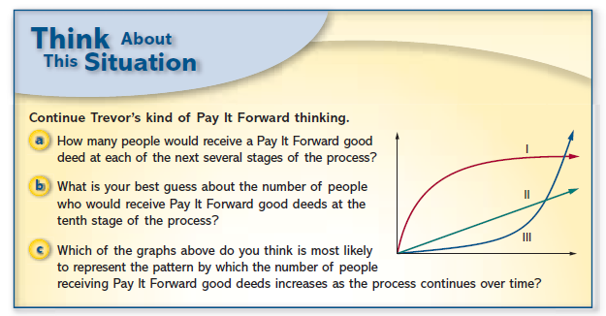

a.

b.

c.

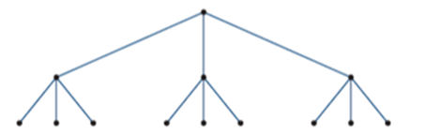1. The number of good deeds in the Pay It Forward pattern can be represented by a *tree graph* that starts like this:

The vertices represent the people who receive and do good deeds. Each edge represents a good deed done by one person for another.

a. At the start of the Pay It Forward process, only one person does good deeds – for three new people. In the next stage, the three new people each do good things for three more new people. In the next stage, nine people each do good things for three more people, and so one, with no person receiving more than one good deed. Make a table that shows the number of good deeds for each stage. Then plot the data.

|  |  |  |  |  |  |  |  |  |  |  |
| --- | --- | --- | --- | --- | --- | --- | --- | --- | --- | --- |
| **Stage** | 1 | 2 | 3 | 4 | 5 | 6 | 7 | 8 | 9 | 10 |
| **# of Good Deeds** | 3 | 9 | 27 |  |  |  |  |  |  |  |

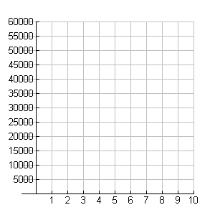

b. The number of good deeds _________________(*one-word answer)* from one stage to the next.

How is this pattern shown in the plot?

c. *For part (c), realize that the table in part (a) shows the number of good deeds done* ***at that stage****, not the total number of good deeds. For instance, at stage 3 there are 27 good deeds done, but the* ***TOTAL*** *number of good deeds done is 3 + 9 + 27 = 39.*

The number of stages needed before 25,000 ***total good deeds*** are done is _______________.

2. Consider now how the number of good deeds would grow if each person touched by the Pay It Forward process were to do good deeds for only two other new people, instead of three.

a. *Make a tree graph for* ***three*** *stages of this model below:*

b. Make a table showing the number of good deeds for the first 10 stages. Then label and plot.

|  |  |  |  |  |  |  |  |  |  |  |
| --- | --- | --- | --- | --- | --- | --- | --- | --- | --- | --- |
| **Stage** | 1 | 2 | 3 | 4 | 5 | 6 | 7 | 8 | 9 | 10 |
| **# of Good Deeds** | 2 | [image]4 | 8 |  |  |  |  |  |  |  |

c. The number of good deeds _________________(*one-word answer)* from one stage to the next.

How this pattern is shown in the plot:

d. The number of stages needed before 25,000 ***total*** good deeds are done is _______________.

3.

a. Recursive equation for Number 1 situation: Recursive equation for Number 2 situation:



b. Write a recursive equation that could be used to model a Pay It Forward process in which each person does good deeds for ***four*** other new people.

4. Why would knowing an **explicit rule** be convenient?

a. The explicit rule for the process in which each person does *three* good deeds for others is which of the following?

A.  B**.**  C.  D. 

How do you know?

b. Write an explicit rule that would show the number of good deeds at stage number *x* if each person in the process does good deeds for ***two*** others.

c. Write an explicit rule that would show the number of good deeds at stage number *x* if each person in the process does good deeds for ***four*** others.

**Summary:**